Edible Cookie Puppets:
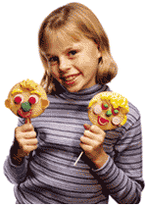
http://familyfun.go.com/recipes/cookie-crafts-for-kids-714703/

